  PROGRAMMING 2B  POE PART 1 | Fortune Nhlakanipho Mlilo ST10213802  MODULE: PROGRAMMING 2B MODULE CODE: PROG6212 LECTURE: DR RODNEY MUSHININGA

- DOCUMENTATION
EXPLANATION OF DESIGN CHOICES, DATA STRUCTURE AND THE GUI LAYOUT
- DESIGN CHOICES
- WINDOWS PRESENTATION FOUNDATION (WPF)
- Windows Presentation foundation is a UI framework designed for the development of stylish desktop programs. WPF offers an ideal basis upon which one can build an interactive, visually appealing, and user-friendly desktop application. In this case, I will design a prototype for Contract Monthly Claim System. This is the reasons why I will use WPF:
- Rich UI Capabilities
- With powerful controls, animations, data binding, and theming, WPF enables you to develop user interfaces of the finest quality.

- Declarative UI designs
- To develop user interfaces, WPF uses Extended Application Markup Language (XAML). As a result, the code may be kept more organized and manageable by separating the visual design from business logic.

- Data Binding
- You can synchronize the user interface with the underlying data thanks to WPF's strong data binding features. For instance, data binding will enable dynamic updating of the fields on the claim submission form and the claim tracking information.

- Rationale
- WPF offers all the features required to design a responsive and easy-to-use user interface for academic managers, program coordinators, and lecturers. The system's comprehensive customization options, which include competent layout controls, templates, and styles, guarantee that it is visually consistent, effective, and easy to use.

- Data Structure
- To contain data about lectures, claims, users, and uploaded documents, the Contract Monthly Claim System needs a well-organized database. This database will be accessed by the WPF front end in order to pull and push data.
- Key Entity in the Database
- Lecture
- Stores information about the user such as LECTURE_ID, NAME, SURNAME AND EMAIL
- Claim
- stores each lecturer's submitted claims, with fields such as CLAIM_ID, LECTURE_ID, HOURS_WORKED, HOURLY_RATE, CLAIM_AMAOUNT, and STATUS (Pending, Approved, Rejected) stored.
- Document
- stores the files uploaded (DOCUMENT_ID, CLAIM_ID, FILE_NAME, FILE_PATH) linked with each claim.
- User
- stores user details (such as username, role, and user ID) for academic managers and program coordinators.

- ENTITY RELATIONSHIPS
- One-to-many relationships
- One lecture can submit multiple claims
- One Claim can have multiple associated Documents
- Users (Coordinators and Managers) can approve or reject multiple claims

- Rationale
- Data integrity
- To eliminate duplication and guarantee data consistency, every table is normalized.

- Document management
- The system can save file paths to uploaded files in the Document table without filling up the database.

- Role-bases access control
- Only authorized people can approve or reject claims thanks to the system's storage of user roles such Academic Manager and Programme Coordinator.

- GUI Layout
- WPF enables us to design a streamlined, user-friendly user interface, which is an important aspect of the CMCS. The layout and features are broken down fully below.

- Lecture Dashboard
- Lecturers will be able to track the progress of their claims, submit them, and provide supporting documentation through their dashboard.

- Claim submission from
- Textbox for hours worked
- enables lecturers to enter the overall number of hours completed.

- Textbox for hourly rate
- Depending on the restrictions of the system, this can either be manually entered or automatically filled in.

- TextBlock to Claim Amount
- Using WPF data binding, the claim amount is presented after being automatically calculated using the formula ClaimAmount = HoursWorked × HourlyRate.

- Upload document button
- There is a button that opens the OpenFileDialog that lets lecturers upload supporting files, such as invoices or timesheets.

- Submit button
- Using the command binding feature of WPF, submits the claim for assessment.

- Claim status track
- With fields like CLAIM_ID, CLAIM_AMOUT, SUBMISSION_DATE, and STATUS, a DataGrid control shows the history of claims.
- Lecturers are able to sort through the claims as needed; they can be sorted by date or status.

- Rationale
- The lecturer's dashboard is meant to be easy to use, basic, and straightforward. By guaranteeing that any modifications made to the input fields (such hours worked), such as WPF's data binding, manual errors in claim amount calculation are avoided.

- Assumptions
- Fixed hourly rate
- Based on system regulations or unique business requirements, will assume that each lecturer's hourly rate is either manually submitted by the lecturer or automatically generated by their profile.

- User authentication managed separately
- The system assumes that login authentication will be managed appropriately.

- User-knowledge
- Program coordinators, managers, and lecturers are indeed computer literate and can use desktop software, such as filling out forms, submitting claims, and uploading documents.

- UML CLASS DIAGRAM

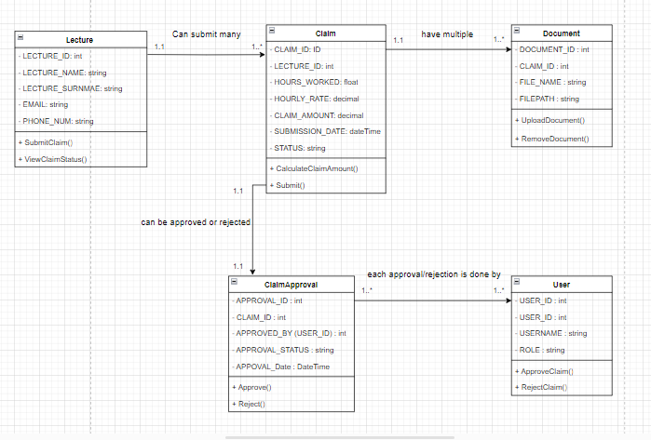

- PROJECT PLAN

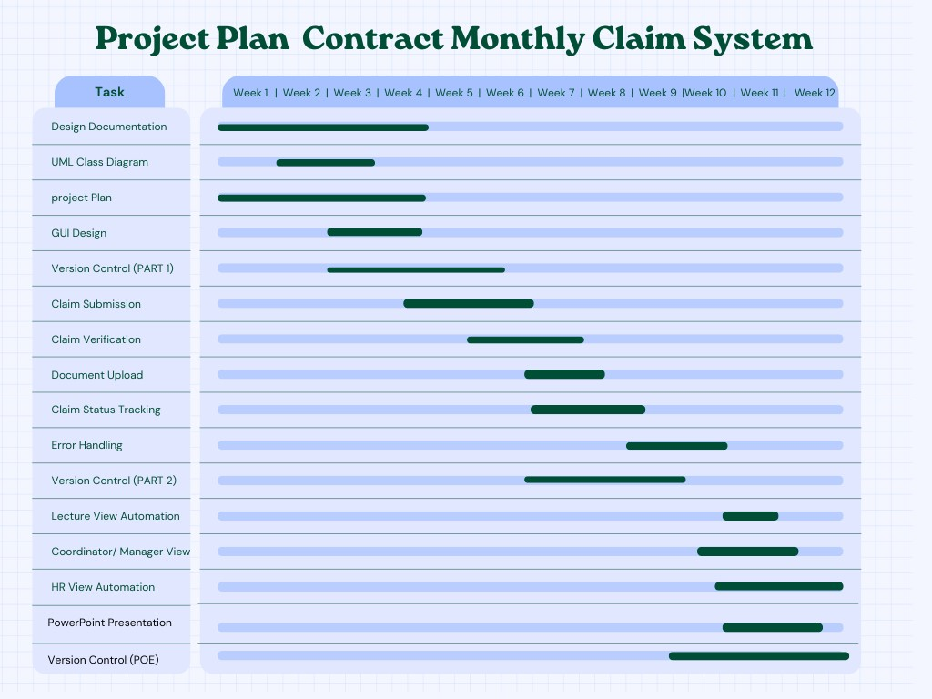

- GUI IU

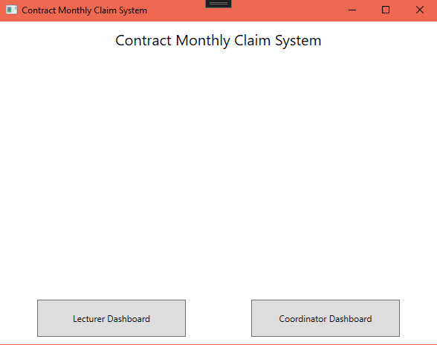

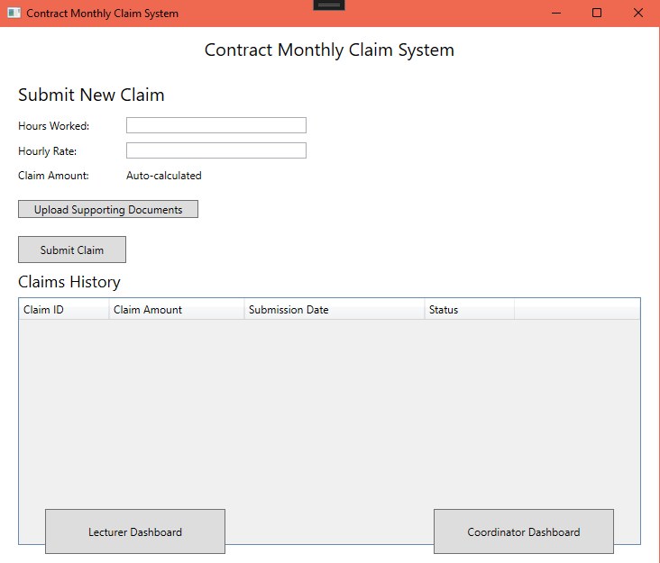

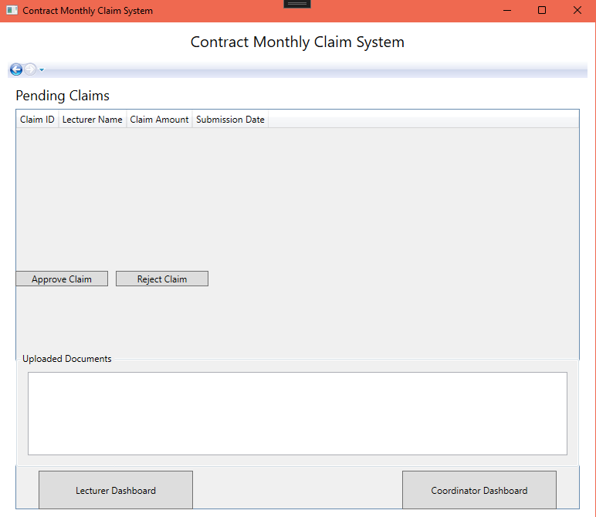

- VERSION CONTROL

